Deep Learning Lab
Problem statement:1

Apply Beale function and find global minimum using gradient learning
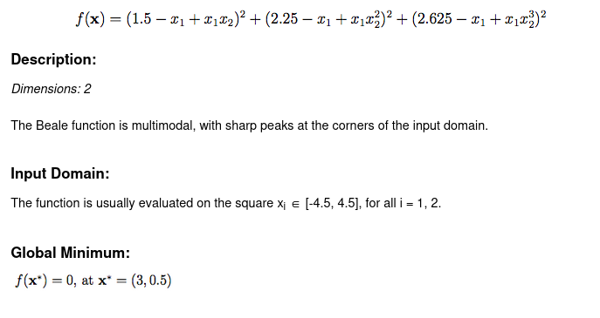

Problem Sheet 2
a.Implement Perceptron model for AND gate
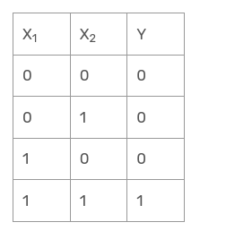
b.Implement multilayer perceptron model for XOR
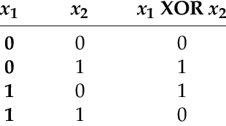
Problem :3
.Training a neural model to detect heart disease:
https://docs.google.com/spreadsheets/d/13o-YsH861jyn3A8o-myEYEtWHyHqJBNA/edit?usp=drive_link&ouid=111231193731952555201&rtpof=true&sd=true

Problem :4

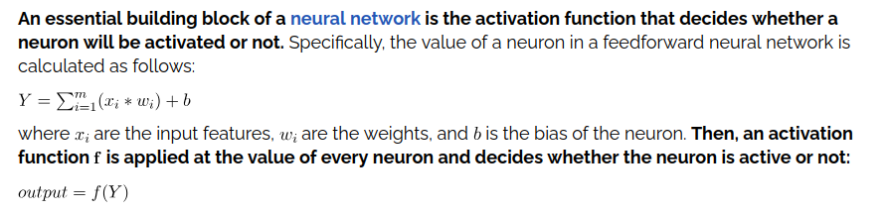

ProblePrSigmoid:
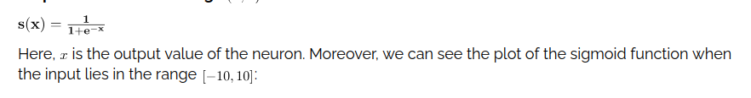
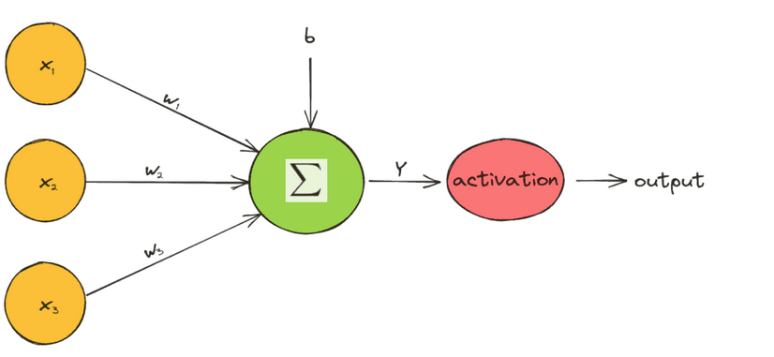

Tanh
Input range:[-10, 10]
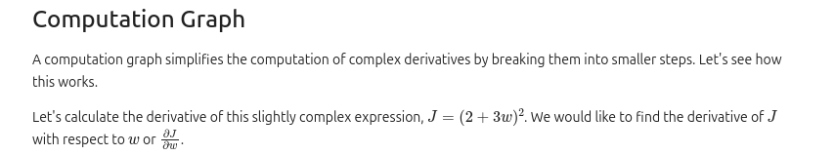

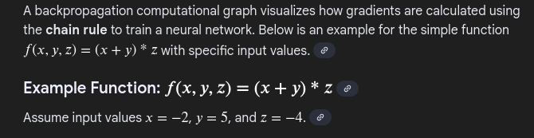

Problem ;5
# 1. Generate small random data (e.g., 100 samples between -5 and 5)
data = np.random.uniform(-5, 5, 100)
Compare different activation function to check their performance
2.Consider a neural network designed to process an input and produce a single binary output (e.g., 0 or 1 for a classification task).
Network Configuration:
- Input Layer: 3 neurons (features).
- Hidden Layer: 2 neurons, using the ReLU activation function.
- Output Layer: 1 neuron, using the Sigmoid activation function.
Given values:
- Input Vector (X): [1, 0, 1]
- Hidden Layer Weights (W):
  - H1 neuron weights: [0.5, -0.2, 0.3]
  - H2 neuron weights: [0.4, 0.1, -0.5]
- Hidden Layer Bias (b): assumed to be 0 for simplicity.
- Output Layer Weights (W): [0.7, 0.2] (corresponding to inputs from H1 and H2).
- Output Layer Bias (b): assumed to be 0 for simplicity.

Task: Calculate the final output of the network using forward propagation.

